# CS 255 System Design Document Template

## UML Diagrams

### UML Use Case Diagram

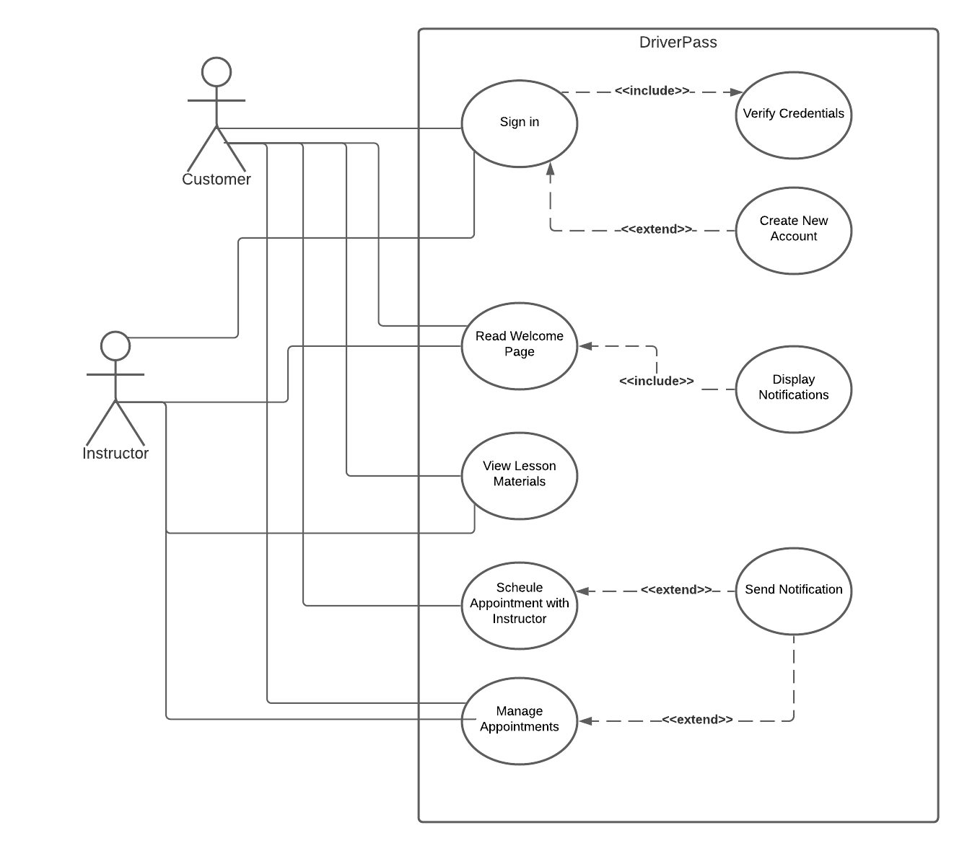

### UML Activity Diagrams

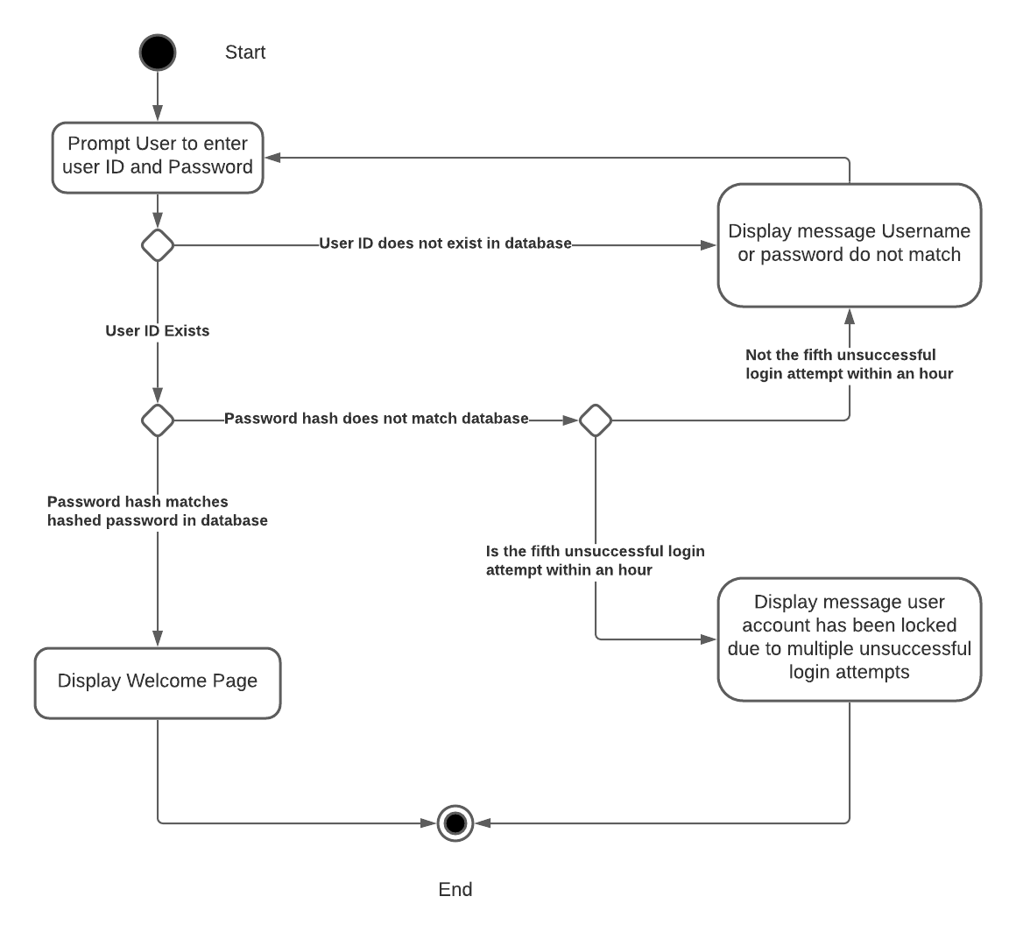

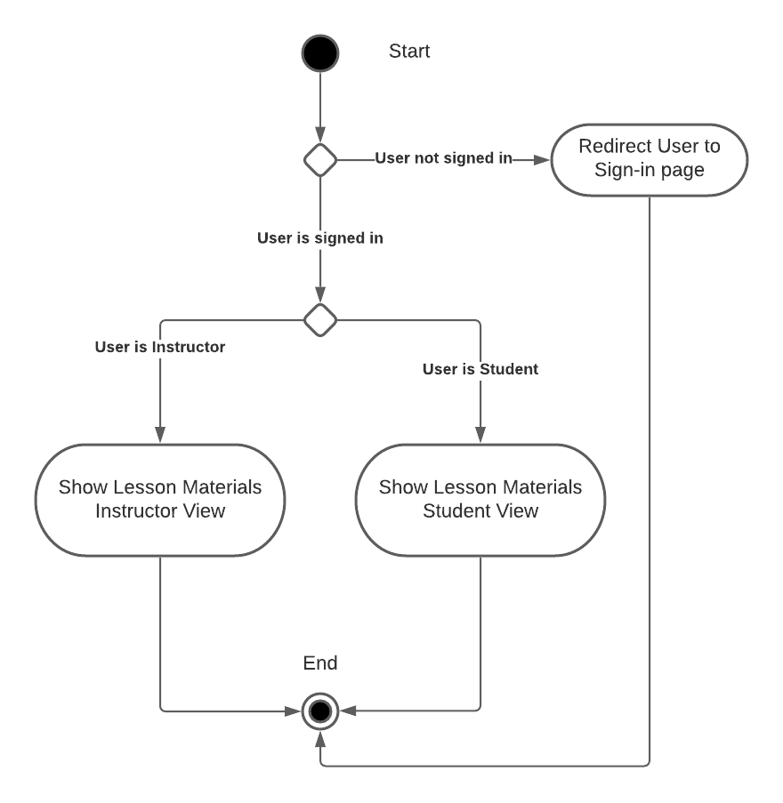

### UML Sequence Diagram

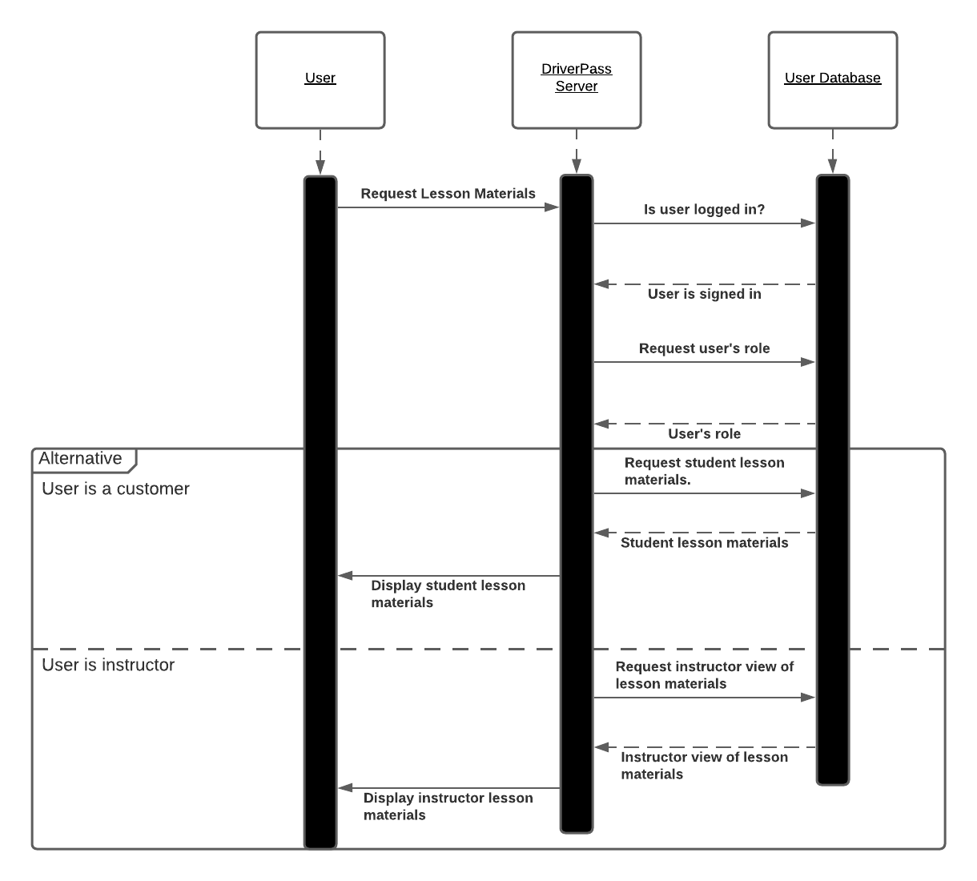

### UML Class Diagram

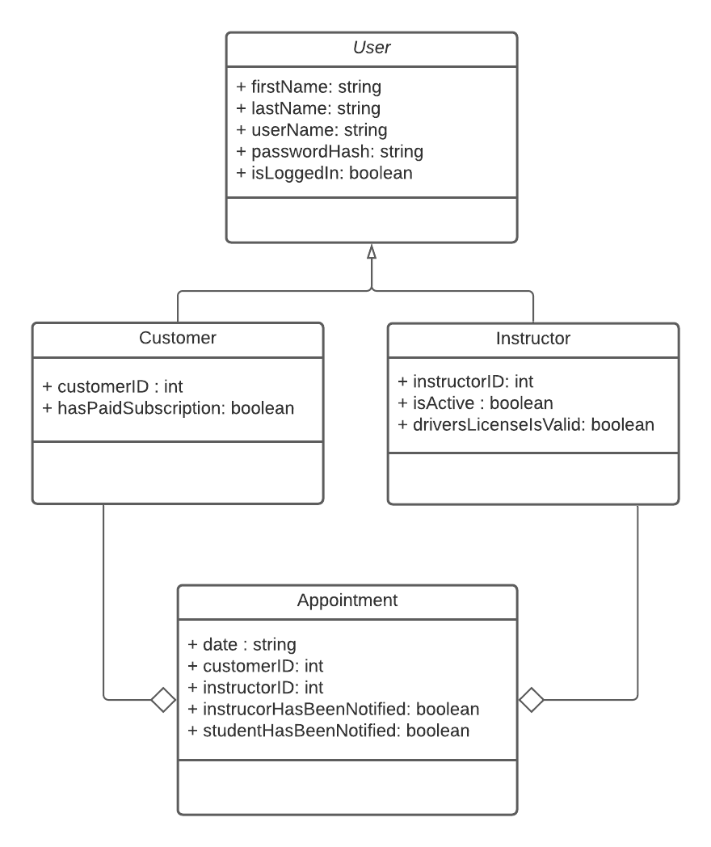

## Technical Requirements

The system is a web application and is designed to run under a LAMP stack. A LAMP stack is a traditional method of hosting a web application. LAMP stands for Linux, Apache, MySQL, and PHP. The server will run on a Linux server. The HTTP server used is Apache. MySQL (or alternatively MariaDB) is used as the database. PHP is a scripting language that handles server-side logic. The server requires power and internet access 24 hours a day. A backup server at an alternative location would be a good idea to have in case of any interruption to the main server’s power or internet connectivity. Some parts of the system can be implemented in other programming languages such as Java or C++ since they contain object-oriented concepts and can interact with the LAMP stack as needed on the server side of the system.

The tools needed to create this website from a software development perspective I recommend is VSCode. VSCode runs on all major operating systems, supports all of the necessary programming languages needed to implement a LAMP stack. VSCode is considered an editor, however, this editor includes support for building applications and debugging from within the application.